Receiving – Alex Marshall

ERD for UX process

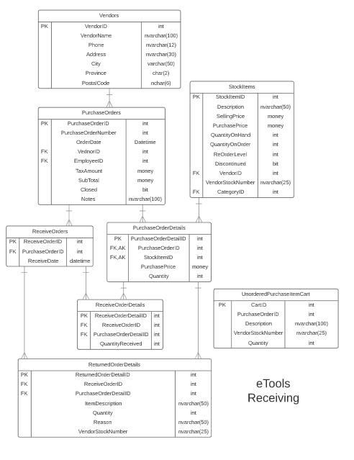

Possible UX Interface

|  |  |  |  |  |  |  |  |  |  |  |  |  |  |  |
| --- | --- | --- | --- | --- | --- | --- | --- | --- | --- | --- | --- | --- | --- | --- |
| Purchase Orders | | | | |  | | |  | | | |  | | |
| Select by ID | | | PO Number | | Order Date | | | Vendor Name | | | | Vendor Phone | | |
| View Order | | | 1401 | | 9/6/2017 | | | HandTools Wholesale | | | | 780-421-1265 | | |
| View Order | | | 1402 | | 10/3/2017 | | | HandTools Wholesale | | | | 780-421-1265 | | |
| View Order | | | 1403 | | 10/9/2017 | | | Hardware International | | | | 403-632-5698 | | |
|  | |  | |  | | |  | | | |  | |
| Receiving | PO Number 1401 9/6/2017 | | | | | HandTools Wholesale | | | | 780-421-1265 | | | |  | |
|  |  | | | | |  | | |  |  | |  | |  | |
| SID | Description | | | | | QtyO | | | QOS | Receive | | Return | | Reason | |
| 23 | Dewalt Multi Speed Drill | | | | | 15 | | | 15 | 15 | |  | |  | |
| 34 | Dewalt Multi Speed Sander | | | | | 23 | | | 10 | 0 | | 15 | | Labeling | |
| 35 | Dewalt Combined Power Set | | | | | 45 | | | 45 | 20 | | 5 | | Broken | |

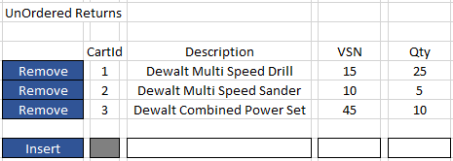

Event and Wiring Summations

|  |  |
| --- | --- |
| **Controls** | **Events** |
| OpenPOListView | None / wired via ObjectDataSource |
| **BBL Class(es) and Method (s)** | |
| PurchaseOrderController,  VendorController | List<PurchaseOrder> List_OpenPurchaseOrders()  Retrieve a list of open purchase orders for listview. Select from purchase orders that are not closed and have a date and purchase order number. Select Purchase Order Number, Order Date, Vendor Name, Vendor Phone, and Purchase Order ID.  Vendor Get_Vendor(int VendorID)  Retrieve vendor information for the open purchase orders. |
| **SQL Table(s): (C,R,U,D)** | **Entities/DTOs/POCOs** |
| PurchaseOrders(R), Vendors(R) | OpenPurchaseOrders(P) |

|  |  |
| --- | --- |
| **Controls** | **Events** |
| ViewOrderButton, OpenPODetailsGridView, PONumberLabel, OrderDateLabel, VendorNameLabel, VendorPhoneLabel | ViewOrderButton OnClick / wired by ObjectDataSource   * Collect PurchaseOrderID * Call BLL |
| **BBL Class(es) and Method(s)** | |
| PurchaseOrderDetailController | List<OpenPurchaseOrderDetails> List_OpenPurchaseOrderDetails (int PurchaseOrderID)  Retrieve a list of OpenPurchaseOrderDetails for supplied PuchaseOrderID. Return PurchaseOrderID (hidden), StockItemID, StockItem Description, Quantity On Order, Quantity Outstanding (Quantity on Order – (sum of QuantityReceived from ReceivedOrderDetails with this PurchaseOrderID), Received Quantity (entry), Returned Quantity (entry), Return Reason (entry) |
| **SQL Table(s): (C,R,U,D)** | **Entities/DTOs/POCOs** |
| PurchaseOrderDetails (R), StockItems(R), ReceivedOrderDetails(R) | OpenPurchaseOrderDetail (P) |

|  |  |
| --- | --- |
| **Controls** | **Events** |
| ReceiveButton, OpenPODetailsGridView, UnOrderedReturns | ReceiveButton OnClick   * Call BLL * Collect all OpenPurchaseOrderDetails in a list * Collect all UnorderedPurchaseItemCart in a list |
| **BBL Class(es) and Method (s)** | |
| ReceiveOrderDetailsController | ReceiveOrder(List< OpenPurchaseOrderDetail>, List< UnorderedPurchaseItemCart>)  Create ReceivedOrder for PurchaseOrderID. Create ReceiveOrderDetail for each row recording quantity received. Adjust StockItem QoH and QoO by StockID.  Create ReturnOrderDetail for each item with quantity returned and reason. Create ReturnOrderDetail for each item in UnOrderedReturns and delete them. If all Purchase OrderDetails have zero QoS, close order. |
| **SQL Table(s): (C,R,U,D)** | **Entities/DTOs/POCOs** |
| ReceiveOrders (C), StockItems (U),  ReceiveOrderDetails (C), ReturnedOrderDetails (C, opt),  UnorderedPurchaseItemCart (R, D), PurchaseOrders (U, opt) |  |

|  |  |
| --- | --- |
| **Controls** | **Events** |
| ForceCloseButton | ForceClose OnClick   * Collect reason |
| **BBL Class(es) and Method (s)** | |
| PurchaseOrderController | ForceClose_PurchaseOrder(int PurchaseOrderID)  Update PurchaseOrder to be closed and record reason.  Decrease StockItem QuantityOnOrder by QoS of PurchaseOrderDetails with associated StockIDs |
| **SQL Table(s): (C,R,U,D)** | **Entities/DTOs/POCOs** |
| PurchaseOrders(U), StockItems(U) |  |

|  |  |
| --- | --- |
| **Controls** | **Events** |
| InsertButton, RemoveButton, UnorderedPurchaseItemCartListView | Insert OnClick / wired by ObjectDataSource |
| **BBL Class(es) and Method (s)** | |
| UnorderedPurchaseItemCartController | Add_UnorderedItemToCart(UnorderedPurchaseItemCart item)  Create new UnorderedPurchaseItemCart  Delete_UnorderedPurchaseItem(UnorderedPurchaseItemCart item)  Delete UnorderedPurchaseItemCart |
| **SQL Table(s): (C,R,U,D)** | **Entities/DTOs/POCOs** |
| UnorderedPurchaseItemCart(C) |  |

Comments

You have a good handle on your subsystem and have indicated the logic within your transactions. Nice work.